**Coding Scenario coding INCORRECTLY:**

Must contain:

An Infusion of Medication

Hydration that begins and ends after the entered Infusion (medication)

An IV push injection that starts within the timeframe of the Infusion (not at the same times as either the Infusion or Hydration)

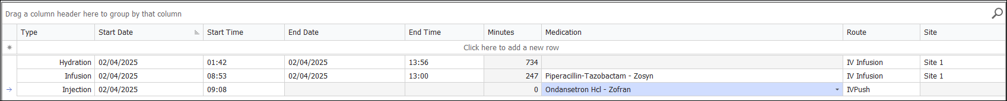

**Reason why this coding is inaccurate:**

Hydration should have only calculated 8 total additional hours (96361) because the time that the Infusion was running would have to be carved out of the total hydration additional hours. The Medication was infused for 4 total hours and based on the time increments entered.

**Coding Scenario coding CORRECTLY:**

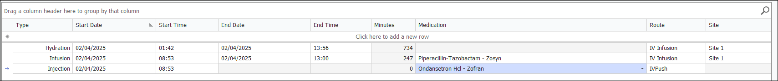

**Coding Scenario coding CORRECTLY:**

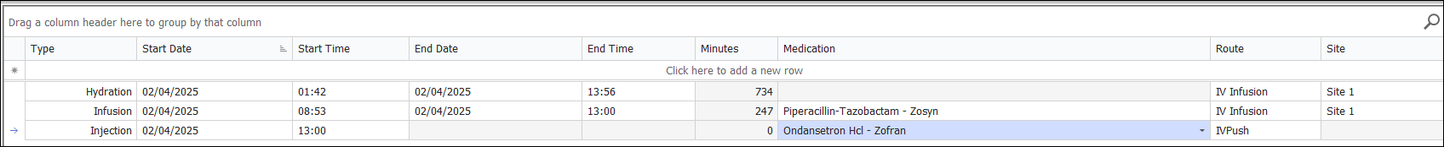

**Coding Scenario coding CORRECTLY:**

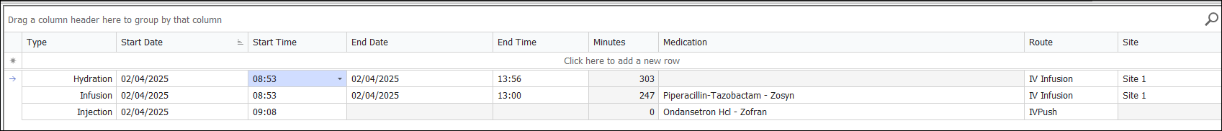

**Coding Scenario coding CORRECTLY:**



**Coding Scenario coding CORRECTLY:**



